Software Testing Assignment

# Module–1(Fundamental)

* What is SDLC

SDLC (Software Development life cycle) is a step by step methods to develop software.

It refers to a methodology with clearly defined processes for creating high quality software.

SDLS is a process to produce software with high quality and lowest cost in shortest time possible. SDLC provides well-structured flow of phases that help an organization quickly produce high quality software, which is well tested and ready for production use.

The SDLC involves six phases of software development.

Requirements

Analysis

Design

Implementation

Testing

Maintenance

* What is software testing?

Software testing is the act of examining the artifacts and the behaviour of the software under test by validation and verification.

Software testing is the process of evaluating and verifying that a software product or application does what is supposed to do.

Testing is executing a system in order to identify any gaps, errors or missing requirement in contrary to the actual desire or requirement.

It is a process used to identify the correctness, completeness and quality of developed computer software.

* What is agile methodology?

Agile methodology is a way to manage a project by breaking it up in to several phase. It involves constant collaboration with client and continuous improvement in every stage. Once the work begins, teams cycle through a process of planning, executing and evaluating.

A practice promote continuous iteration of development and testing throughout the software development lifecycle of the project.

* What is SRS

SRS (Software requirement specification) is a document that describes what the software will do and how it will be expected to perform. It also describes the functionality the product needs to fulfil the needs of all uses. It is a blue print or road map of the software development.

* What is oops

Object- oriented programming is a programming paradigm based on the concept of the objects, which can contain data and code. The data is in form of fields and the code is in the form of procedures.

* Write Basic Concepts of oops

Oops (Object- oriented programming) is a model that provides different types of concepts, such as inheritance, abstraction, polymorphism, etc. These concepts aim to implement real world entities in programs and they create working methods and variables to reuse them without compromising security.

* What is object

In object – oriented programming (OOP), object are the first things you think about first in designing a program and they are the units of code that are eventually derived from process.

* What is class

A class is a template definition of the methods and variables in a particular kind of object. Thus, an object is a specific instance of a class. It contains real value instead of variables.

Class is a set of related objects with common characteristics.

* What is encapsulation

Encapsulation is a way to restrict the direct access to some components of an object, so users cannot access state values for all the variables of a particular object.

Encapsulation can be used to hide both data members and data functions or methods associated with an instantiated class or object.

* What is inheritance

Inheritance allows programmers to create classes that are build upon existing classes, to specify a new implementation while maintaining the same behaviours to reuse code and to independently extend original software via public classes and interface.

* What is polymorphism

Polymorphism is a feature of object- oriented programming language that allows a specific routine to use variable of different types at different times.

It helps to performs many different operations using a single entity.

* Draw Usecase on Online book shopping

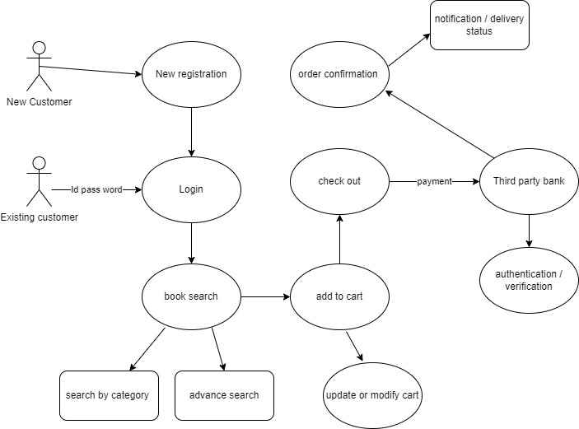

* Draw Usecase on online bill payment system (paytm)

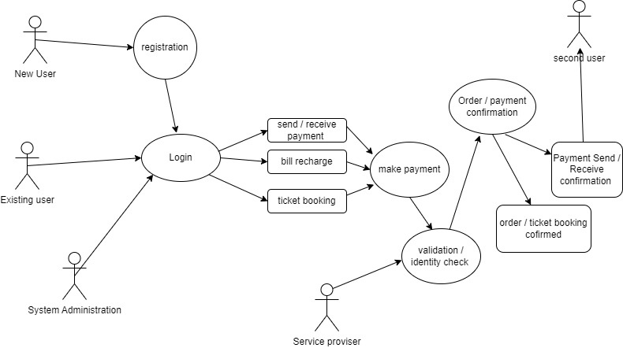

* Write SDLC phases with basic introduction

SDLC has main six types of phases as below

Requirement – establish customer needs.

Analysis – model and specify the requirement “what”

Design – Model and specify a solution “why”.

Implementation – Construct a solution in software

Testing – Validate the solution against the requirements.

Maintenance – Repair defects and adapt the solution to the new requirements.

* Explain Phases of the waterfall model

The water fall model is a sequential design process in which progress is seen as flowing steadily downwards though the phases of conception, Initiation, Analysis, Design, Construction, Testing, Implementation and Maintenance.

* Write phases of spiral model

The spiral model has four phases – Planning , risk analysis, product development and next phase planning or evaluation. A software project repeatedly passes through these phases in iterations

* Write agile manifesto principles

The four core value of agile software developments as stated by the agile manifesto are-

Individuals and interactions over processes and tools.

Working software over comprehensive documentations.

Customer collaboration over contract negotiation

Responding to change over following plan.

* Explain working methodology of agile model and also write pros and cons.

The agile methodology is a way to manage a project by breaking it up into several phases.

Agile model believes that every project needs to handle differently and the existing methods need to tailored to best suit the project requirements.

In agile the tasks are divided to time boxes to deliver specific features for a release.

Pros:-

Its very realistic approach to software development.

Promote team work and cross training.

Functionality can be developed rapidly and demonstrated

Suitable for fixed or changing requirements

Cons

Not suitable to handle complex dependencies.

There is a very high individual dependency as there is minimum documentation required.

Transfer of technology to new team member may be quite challenging due to lake of documentations.

* Draw usecase on Online shopping product using COD.

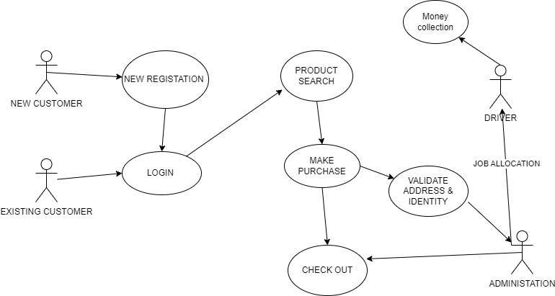

* Draw usecase on Online shopping product using payment gateway.